School Accountability Committee (SAC) Manual
Version 1

November 2021

Table of Contents

Contents
Welcome to the CILA School Accountability Committee 4
Role and Purpose of SAC 4
School Budget 4
School Improvement 5
Principal Development Plans and Evaluations Error! Bookmark not defined.
Parent & Family Engagement 5
SAC Self Assessment 6
Relationship with Parent Groups and School Teams 6
Parent Organizations 6
Board of Directors 6
Representation and Membership 6
Minimum Membership 6
Membership Roles and Terms 7
Recruitment of Members 7
Organization 8
Member Roles & Responsibilities 8
Meetings and Procedures 9
Meetings 9
Scheduled Meetings 9
Non-scheduled Meetings 9
Decision Making 9
Attendance 10
Agendas 10
Minutes 10
Bylaws 10
Member Norms 10
School Finance 11
Unified Improvement Planning (UIP) 12
Parent Engagement 13
National Standards for Family-School Partnerships 13
References 14
Additional Resources 14
Appendices 15
Appendix A: SAC Responsibilities Inventory 15
Appendix B: Sample SAC Recruitment Letter 17
Appendix C: Quarterly & Monthly Responsibilities Sample Calendar 18
Appendix D: Sample Agenda 19
Appendix E: Example Minutes 20
Appendix F: Sample SAC Member Norms 22
Appendix G: Engaging with the UIP 23
Improvement Planning 23
Implementation of Improvement Plans 24
Appendix H: Engaging with the School Budget 25
Spending Priorities 25
Appendix I: Supporting Parent Engagement 26
Procedure for providing feedback about this manual 29
Contributors 29

Welcome to the CILA School Accountability Committee
The School Accountability Committee (SAC) is a state mandated committee that allows community members to be involved in educational improvement at a school. It is through the cooperative efforts of teachers, parents, staff, administrators, students, and community members that foundations for school improvement are built.

This School Accountability Committee manual is a resource to support the success of accountability programs and school improvement processes within CILA. This manual conforms to guidelines, policies, and statutes from the state of Colorado and the Colorado Springs District 11 Board of Education. Practices required by state law and local
policy are noted as such. Recommended practices may be tailored to fit individual school needs and circumstances.

Role and Purpose of SAC
A School Accountability Committee is a representative advisory committee. The usual name of this committee is “CILA School Accountability Committee,” and it is normally referred by the acronym SAC. The SAC is an advisory team that looks at school goals, reviews school budgets, supports parent engagement, and drives school improvements. The school’s Principal is ultimately responsible for ensuring compliance with all federal, state, and district requirements and meeting the academic performance expectations defined by the District 11. Based on state statute and District 11 policy, at a minimum, the SAC is responsible for the following:

School Budget
- Recommend priorities for spending school monies, including federal funds, where applicable, prior to adoption of the school budget. The SAC provides recommendations to the school principal. (Legal reference: CRS 22-11-402(1) (a))
  - This review should ensure that funds and spending priorities align with the school’s Unified Improvement Plan (UIP) and core values of the school to benefit all students.

School Improvement
- Provide annual input to the principal and superintendent regarding the schools Unified Improvement Plan (UIP). (Legal reference: CRS 22-11-402(1) (b)).
- Meet at least quarterly to review and discuss whether school leadership, personnel, and/or infrastructure are advancing or impeding implementation of the UIP and student performance. (Legal reference: CRS 22-11-402(1) (d))
- For schools with Priority Improvement or Turnaround plan types, the SAC should:
  - Publicize and hold a SAC meeting and public hearing pursuant to section 22-32-142 (2) or 22-30.5-520 (2) to discuss strategies to include in a public school priority improvement or turnaround plan, prior to the plan being written. (Legal reference: CRS 22-11-402(1) (f, g))

Parent & Family Engagement
- Increase the level of parent engagement in the school. The committee's activities to increase parent engagement must include, but need not be limited to:
  - Publicizing opportunities and soliciting parents to serve on the SAC. The SAC shall make efforts to help ensure that parents who serve (on the SAC) reflect the student populations that are significantly represented within the school. (Legal reference: CRS 22-11-402(1)(h)(I))
    - A sample parent recruitment letter can be found in Appendix B.
  - Assist District 11 in implementing, at the school level, the district’s family engagement policies. (Legal reference: CRS 22-11-402(1)(h)(II))
  - Help school personnel increase parents' engagement with teachers, including but not limited to: creating students' READ plans, individual career and academic plans, and plans to address habitual truancy. (Legal reference: CRS 22-11-402(1)(I)(III))
- The Starting Points Inventory of Family-School-Community Partnerships is a great way to see how your school approaches family engagement compared to national standards.

SAC Self Assessment
It is recommended that each SAC conduct an annual self-assessment to see how well they are adhering to the aforementioned duties. A SAC Responsibilities Inventory can be found in Appendix A.

Relationship with Parent Groups and School Teams

Parent Organizations
It is recommended that the SAC and the Parent Teacher Organization/Parent Teacher Association (PTO/PTA) be separate committees. In general, PTO/PTA emphasizes fundraising, coordinates school volunteers, organizes community events, etc. In the interests of better communication between SAC and PTO/PTA, a member of either body could be designated to serve as a liaison between the SAC and the PTO/PTA communities.

Board of Directors
It is recommended that the SAC and CILA Board of Directors have a collaborative relationship and attendance at designated meetings. The SAC encourages one member of the SAC to attend to the regularly scheduled Board of Director meetings.

Representation and Membership

Minimum Membership
Each district public school and each institute charter school shall establish a school accountability committee. Each school accountability committee shall consist of at least seven members (Legal Reference: CRS 22-11-401(1)(a)):
- One principal, or principal's designee
- One teacher who provides instruction at the school
- Three parents or legal guardians of students enrolled at the school
- One adult member of an organization of parents, teachers and students recognized by the school (i.e. PTO/PTA/PTSA, etc.)
- One Community Representative - a person who is involved in business or industry in the community

Membership Roles and Terms
- Members of the SAC shall serve a term of one year, which is renewable.
- A person may not serve more than one of the required membership roles on the SAC. (Legal Reference: CRS 22-11-401(1)(c))
- Annually, each SAC shall elect a parent representative to serve as chairperson or vice/co- chairperson of the committee. (Legal Reference: CRS 22-11-401(2)). SAC chairpersons will serve one year terms, which may be extended if other members cannot be found. It is suggested that no SAC member be eligible for the office of the chairperson for more than two consecutive years.
- Members of the governing board of a district charter school or an institute charter school may serve as members of the school accountability committee. (Legal Reference: CRS
22-11-401(4)(b))

Recruitment of Members
- Members of the SAC shall be appointed by the principal of each school. The principal shall ensure, to the extent practicable, that the persons appointed reflect the student populations significantly represented within the school.
- If a SAC has more members than listed in the Minimum Membership section, the number of parents appointed must exceed the number of representatives from the group with the next highest representation.
- If a vacancy arises on a school accountability committee because of a member's resignation or disqualification or for any other reason, the remaining members of the school accountability committee shall fill the vacancy by majority action. (Legal Reference: CRS 22-11-401(3))

Organization

Member Roles & Responsibilities

SAC Role | Responsibilities
Principal or Designee | - Provide the Unified Improvement Plan to the SAC for review  - Provide budgetary information to the SAC for review  - Oversee elections for SAC membership (if needed), and to recruit likely candidates for SAC  - Provide various reports, raw data, and specific information requested by SAC members  - Assist in reviewing implementation of the School Improvement Plan  - Act as a liaison between SAC and the school community, between SAC and Board of Directors, and between SAC and the Colorado Charter Institute, if necessary
Chairperson | - Facilitate all meetings - keep members on task, focus discussions, and limit discussions appropriately  - Set meeting agendas in collaboration with the principal  - Guide the team in reviewing goals and other elements of the UIP  - Guide the team in making budgetary recommendations
Vice/Co- Chairperson | - Fulfill all of the above in the absence of the chairperson
Secretary/Recorder | - Record and distribute minutes of SAC meetings in collaboration with the principal  - Type and distribute meeting agendas  - Place public notice of upcoming meetings  - Keep the “SAC Manual” and a copy of the SAC bylaws (if adopted) current, and place these documents on the school website, or in a location that can easily be referenced by any member of the school community  - Keep attendance record for meeting minutes
Faculty Representative | - Act as a liaison between SAC and the faculty at large  - Bring faculty concerns to SAC meetings  - Facilitate communication with parents on SAC matters and to assist in raising parent interest in participating on SAC
Parent Representative | - Bring parent concerns to SAC meetings  - Provide parents’ perspectives on school issues  - Help communicate school concerns to the broader community
Community Representative | - Help raise awareness of neighborhood/community issues  - Help communicate school concerns to the broader community

Subcommittees
These may be formed as needed, and appointed by the chairperson. They should be provided with a purpose or charge, such as addressing action strategies related to achievement, equity, and/or school climate, for example. After completion of the given task, the subcommittee should submit a report to SAC for review and inclusion in the minutes.

Meetings and Procedures
All school accountability committee meetings shall be open to the public. Notices for SAC meetings shall be posted in the school.

Meetings

Scheduled Meetings
SACs must meet ...at least quarterly to discuss whether leadership, personnel, and infrastructure are advancing or impeding implementation of the plan. It is recommended that SAC meetings be scheduled regularly, ideally once per month during the school year. It is recommended that the SAC meeting be scheduled to align monthly with the Board of Directors meeting to help facilitate the dissemination of information to the school community. See Appendix C for sample calendars for quarterly and monthly responsibilities.

Non-scheduled Meetings
The principal or the chairperson may call non-scheduled meetings, as needed. For example, to review portfolio components prior to submission to the district. Sufficient notice should be given for such meetings.

Decision Making
- Use Robert’s Rules of Order as a reference for parliamentary procedures and group operations for cases not covered in this manual or in the SAC’s bylaws.
- All SAC members are to be considerate of differing viewpoints, and are to make decisions in the best interest of the entire school.
- Decisions should be made via consensus, or general agreement. If the chairperson determines that a consensus is not possible, a call for a vote can be initiated.
- Voting: A quorum must be present for all matters that require a vote. A quorum shall consist of more than half of the total SAC membership, unless otherwise specified in the SAC bylaws. Only SAC members may vote.

Attendance
SAC members are encouraged to inform the chairperson in advance of any absences.

Agendas
Agendas are essential to keep meetings on track and on time. Send meeting agendas at least 2 days before each meeting, along with a reminder of the meeting date and time. Many topics on a SAC agenda are determined by the cycle of school improvement planning. SAC members may need background information or training in order to work effectively during the meeting. Include an open forum at the end of each meeting to allow SAC members to share concerns or request specific topics for future meetings. A sample agenda is shown in Appendix D.

Minutes
Minutes shall be written for each meeting by the secretary/recorder. Minutes are to be distributed to SAC members, along with the agenda for the following meeting, where they will be presented for approval. Approved meeting minutes will be publicly published in a timely manner and regularly distributed through school’s standard communication practices. Example meeting minutes can be found in Appendix E.

Bylaws
In the interests of facilitating SAC operations, it is strongly recommended that each SAC develop, and periodically review, bylaws to govern the operations of the group.

Member Norms
It is recommended that each SAC establish, and agree to, a set of group expectations for behavior and best practice. Norms are independent of bylaws. Example SAC norms can be found in Appendix F.

School Finance
Colorado public schools receive funding from a variety of federal, state and local sources, most of which are provided through the Public School Finance Act of 1994. If you would like detailed information on school finance, we encourage you to read Understanding Colorado School Finance And Categorical Program Funding.

One of the statutory requirements of the SAC is to recommend school spending priorities. These priorities should be aligned with the school improvement planning strategies and core values. Relevant data that supports effective use of funds on increasing student performance should also be considered.

See Appendix H for information on how your SAC can engage in the budget planning process.

Unified Improvement Planning (UIP)
In 2009, the state of Colorado introduced the Unified Improvement Plan (UIP) to streamline the improvement planning components of state and federal accountability statutes. The plan is intended to be used as a continuous cycle of improvement. A key requirement of SAC is to provide annual input on the development of the school’s UIP and monitor progress towards implementation (of the plan) at least quarterly. The UIP process begins with a data review (e.g., student performance data, process data about the school) and then identifies ambitious targets and an action plan to direct next steps.

The chart below translates some of the key terms in the UIP process and provides some examples.

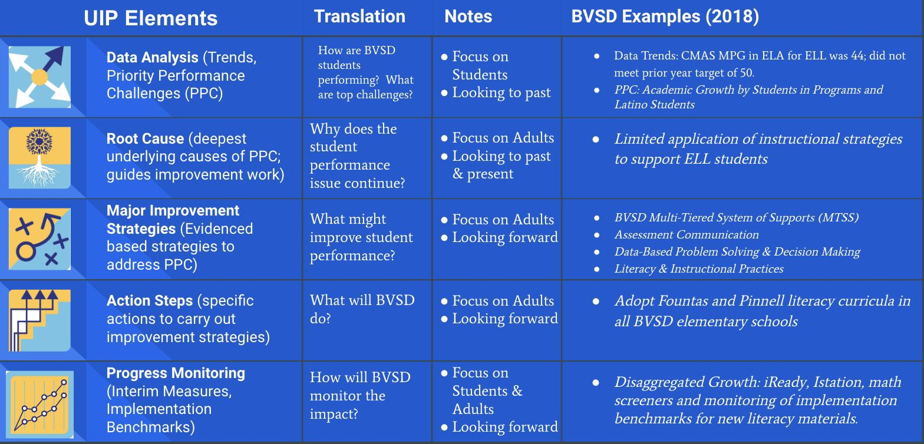

Colorado statute requires the Colorado Department of Education (CDE) to assign every school to one of four plan types based on their current performance. These include: Performance, Improvement, Priority Improvement, or Turnaround. The plan type determines the level of attention the school receives from the state – for increased state scrutiny of plans and additional state support. Each year, schools consider newly available state and local performance data to write/update a two-year UIP (one that includes the current and the next school year). Schools and districts are required to publicly post their improvement plans through the CDE website on SchoolView, allowing external stakeholders to learn about improvement efforts. Additional information can be found on the CDE website.

See Appendix G for information on how your SAC can engage in the improvement planning process.

Parent Engagement

National Standards for Family-School Partnerships
Directly quoted from: “Successful Family-School Partnerships.” National PTA,
www.pta.org/home/run-your-pta/National-Standards-for-Family-School-Partnerships. Accessed July 31, 2019.
- Welcoming All Families into the School Community: Families are active participants in the life of the school, and feel welcomed, valued, and connected to each other, to school staff, and to what students are learning and doing in class.
- Communicating Effectively: Families and school staff engage in regular, two-way, meaningful communication about student learning.
- Supporting Student Success: Families and school staff continuously collaborate to support students’ learning and healthy development both at home and at school, and have regular opportunities to strengthen their knowledge and skills to do so effectively.
- Speaking Up for Every Child: Families are empowered to be advocates for their own and other children, to ensure that students are treated fairly and have access to learning opportunities that will support their success.
- Sharing Power: Families and school staff are equal partners in decisions that affect children and families and together inform, influence, and create policies, practices, and programs.
- Collaborating with Community: Families and school staff collaborate with community members to connect students, families, and staff to expand learning opportunities, community service and civic participation.

See Appendix I for information on how your SAC can support Parent Engagement in your school.

References
- The Education Accountability Act of 2009 (SB 09- 163)
- Rules For The Administration Of The Accreditation Of School Districts (1 CCR 301-1) Version dated: 11/14/2016
- Colorado Department of Education Website
- SAC Policies and Resources
  - CRS 22-11-401 School accountability committee: creation, qualifications, elections
  - CRS 22-11-402 School accountability committee: powers, duties & meetings

Additional Resources
- Robert’s Rules of Order, by Henry M. Roberts III.
- Multi Tiered System of Supports from CDE (MTSS)
- Unified Improvement Plan from CDE (UIP)
- School Finance
  - Colorado Department of Education - School Finance
- Family Engagement
  - Family-School-Community Partnerships - CDE
  - Family Engagement Promising Practices Training Manual - CDE
  - Promising Practices - CDE
  - National Standards, Goals, and Indicators for Family-School Partnerships
  - Partners in Education: A Dual Capacity-Building Framework for Family–School Partnerships

Appendices

Appendix A: SAC Responsibilities Inventory

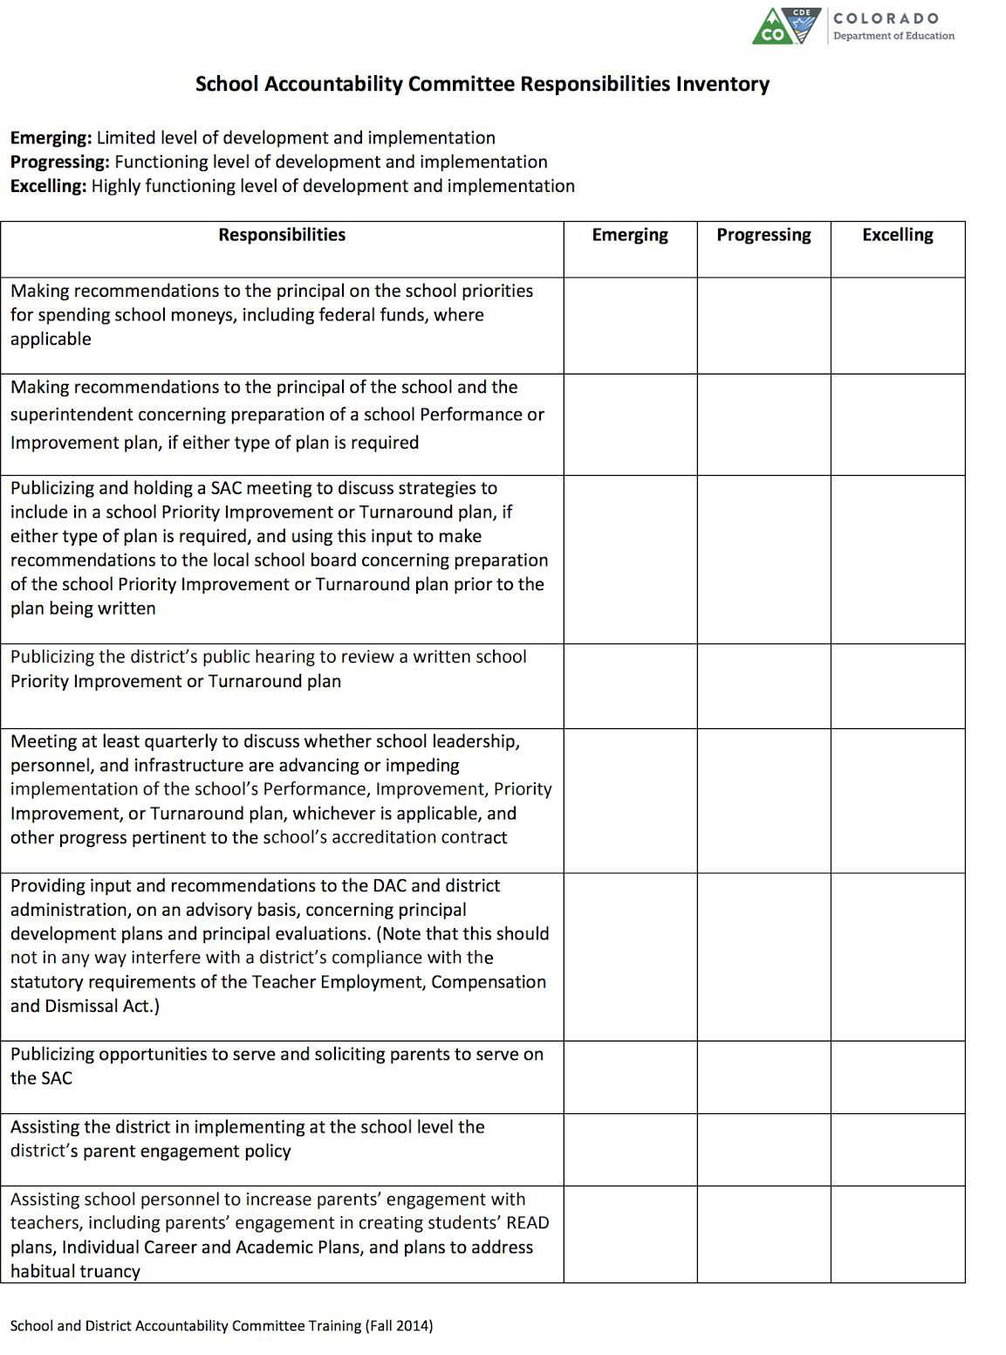

SAC Requirements & Best Practices
Requirements for All School Accountability Committees
Meet SAC Membership Minimums:
- one or more teachers
- three or more parents or legal guardians of students attending the school (number of parents must
outnumber members from other groups)
- one adult member of an organization in service to the school (PTO, FET, etc.)
- one community representative
- recruit and select a parent representative to serve as SAC chairperson or co-chairperson
- recruit and select a representative to serve on the District Accountability Committee
Schedule meetings and convene at least quarterly
Review, discuss and provide recommendations on the school's Unified Improvement Plan
Hold a public SAC meeting to provide input on Priority, Performance and Turnaround Improvement
Plans prior to submission to the district
Publicize all SAC meetings and provide opportunities for parents to serve on SAC
Recommend, to the Principal, priorities for spending school moneys
Increase the level of parent engagement at the school
Assist the school in implementing the family engagement policy
Best Practices for SACs
SAC Members receive and read the SAC Manual annually
Recruit and identify a representative to be the Secretary / recorder.
Prepare and distribute a meeting agenda at least one week prior to the scheduled meeting (on school
website, calendar or via regular communication)
Publish the minutes written by the secretary/ recorder on a school website or otherwise distribute to the
entire school community.
Address and implement a means to meet the 7 Standards for Family-School Partnerships
Conduct a mid-year budget review
Adopt SAC Bylaws and Member Norms
Ensure parents on the SAC reflect the student populations significantly represented within the school
Critique and address topics affecting achievement, equity, school culture, etc.
Exceptional SAC Practices
Discuss Teaching & Learning Conditions Colorado (TLCC) survey results (typically available in May)
Discuss student climate survey results (typically available in March)
Discuss Parent Input survey results (typically available in April/May)
Conduct a mid-year review of Family Engagement practices
Review the most critical school areas needing attention or improvement

Appendix B: Sample SAC Recruitment Letter
The following letter was adapted from the Durango School District SAC Handbook.

Our School Needs You!

Are you a parent who likes to think big, dig into data, and advocate for improvement? Do you value consensus-based decision making and enjoy supporting your local school? If so, the <school name> School Accountability Committee (SAC) may be the place for you!

The purpose of the SAC is to inform, encourage, and provide opportunities for parent and community members to be involved in the planning and evaluation of the school’s budgetary and improvement processes. This means we discuss things like:

- Unified Improvement Plans (the school’s academic goals and action plans)
- Budget priorities
- Safety issues
- Parent Engagement

We need parent and community representatives that reflect our school’s amazing diversity to join our SAC. Becoming a member of the SAC means:
- Attending SAC meetings which must happen quarterly, but may happen monthly. The time and dates of the meetings will be decided by the SAC in order to accommodate the schedules of our community to ensure the greatest opportunity to attend.
- Becoming informed about school programs and budgets - specialists may be invited to SAC meetings to help educate the members.

Being a voice for our school.

We are currently assembling our SAC for the next school year. Nominations and an election are required to fill the following parent positions: Chairperson, Vice Chairperson, Recorder/Secretary. You don’t need to be in one of the elected positions to be a part of the SAC - the more parents involved, the better! If you are interested in nominating yourself or another person for an elected position, or participating in the SAC, please contact <insert name and email>. Nominations will be accepted until <date>. The nominations will be presented to the parent community and voting with take place from <date-date>. We look forward to your participation on our SAC!

Appendix C: Quarterly & Monthly Responsibilities Sample Calendar
The following is a list of monthly and quarterly agenda items. The SAC Chair and Principal should work together to develop a plan that meets the particular needs of the school community.
Qtr. | Month | Agenda Items
Q1 | August/ September | - Welcome new members  - Provide SAC manual to all members for review and to ensure compliance  - Review survey results: student climate, parent and TLCC if not reviewed in May  - Review prior-year results from state/local assessments  - Review results from the Family Partnership survey and identify 1 goal for the school; consider including this goal as the third UIP goal.  - Provide input on the UIP that is aligned with the school and district strategic plans  - Priority Improvement and Turnaround Plan schools: publicize the SAC meeting to discuss strategies for the UIP
 | October | - Complete SAC Budget Survey on school and district spending priorities  - Discuss planned expenditures from school grants or PTO funds (if available)  - Discuss any school safety issues  - Review student enrollment from October count
Q2 | November | - Discuss implementation of UIP - provide input on major/urgent challenges and improvement strategies  - Discuss mid-year Family Engagement practices and progress towards goal  - Discuss Open Enrollment (OE) events and marketing
 | December | - If needed, publicize a public hearing to review a Priority Improvement or Turnaround plan  - Review the Student Performance Framework
 | January | - Review mid-year test/assessment results (if available)  - Mid-year UIP progress report  - Discuss upcoming student assessment window and testing schedule  - Mid-year review of school budget
Q3 | February | - Encourage families to take the district Parent Snapshot Survey  - Discuss mid-year Family Engagement practices and progress towards goal
 | March | - Conduct student climate survey, if participating  - Review staffing and budgetary allocations for subsequent year  - Recommend school budget priorities for the following year
 | April | - Review UIP implementation. Make recommendations regarding preparation and content of UIP for following year  - Start recruiting SAC members for the following school year  - Complete SAC Responsibilities Inventory
Q4 | May | - Review results from student climate and parent surveys  - Elect officers for following year  - Determine and publish SAC meeting schedule for following year  - Reflect on ways to improve adherence to SAC Responsibilities in the following year  - If requested, provide input and recommendations regarding development plans and evaluations for the school principal.
 | June/July | - Optional planning meeting for upcoming year

Appendix D: Sample Agenda

School Name: School Accountability Committee
Date: Time: Place:

AGENDA
- Call to order, welcome
- Celebrations
- Agenda review
- Approval of minutes (from previous meeting)
- Principal’s Report
  - Possible topics include: Update on current enrollment, major changes, safety issues/concerns, project updates, etc.
- PEN/DPC/PTO Report, if applicable
- Discussion items
  - Old Business Items
  - New Business Items
- Set agenda for next meeting (if not set by Principal & SAC Chair at subsequent meeting)
- Adjournment

PRE-READING MATERIALS:
Please make sure to read all documents listed below prior to the meeting.
- <Include items needed here>

Appendix E: Example Minutes

<Insert School Name> School Accountability Committee Minutes
Date: |  | Time:
Facilitator: |  | Secretary/Recorder:
Principal or Designee:
Attendees:

School Summary
Current Year Positions Chair:  Co-Chair:  Secretary: Teacher Rep:  DPC:  Community Rep: PTO/PTA/PTSO Rep: | Last Year Positions Chair:  Co-Chair: Secretary: Teacher Rep:  DPC Rep:  Community Rep:  PTO/PTA/PTSO Rep:
Remaining Meeting Dates:
Introduction/Review of Minutes
- Presenter:
- Discussion Notes:
- Conclusions and or approval by SAC participants at previous meeting:
Principal Report
- Presenter:
- Discussion Notes:
- Conclusions:
Action Items | Person Responsible | Deadline
●
Review of UIP
- Presenter:
- Discussion Notes:
  - Numeracy & Literacy:

  - School Culture & Climate:

  - Other:
- Conclusions:

Action Items | Person Responsible | Deadline
●
Review of Budget, Family Engagement Practices, Principal Development Plans as necessary per State Statute
- Presenter:
- Discussion Notes:
- Conclusions:
Action Items | Person Responsible | Deadline
●
Other Orders of Business:
- Presenter(s):
- Discussion Notes:
- Conclusions:
Action Items | Person Responsible | Deadline
●
Meeting Adjourned | Person Responsible | Time

Appendix F: Sample SAC Member Norms
Below are suggested norms, adapted from the JeffCo SAC Resource Manual.

SCHOOL ACCOUNTABILITY COMMITTEE MEMBER NORMS:

- Members will make every effort to attend each meeting;

- Meetings will begin and end on time;

- Members will respect the opinions of others and be considerate of differing points of view;

- Only one person will speak at a time; no side conversations;

- Monitor personal technology (turn cell phones off/on vibrate, close laptops during discussion);

- Members will take care of personal needs at their own discretion;

- Discussion and decisions will be limited to topics that are within the scope of the SAC responsibilities and on the agenda;

- Each committee member will have an equal voice.

Appendix G: Engaging with the UIP

Improvement Planning
It is a duty and power of SAC to advise the principal. . . concerning the preparation of a school performance or improvement plan. . . and to submit recommendations to the principal . . . concerning the contents of the performance or improvement plan. There are several possible ways in which SAC’s may engage in the UIP planning process. Below is a non-exhaustive list; the listed methods are not necessarily mutually exclusive.
- The SAC identifies a) persistent patterns in school data, b) root causes of problematic patterns, and c) action steps to address the root cause(s). Any root causes identified must be within the control of adults in the school. Depending on data studied, parent/community team members may be asked to sign confidentiality agreements.
- SAC receives information needed to help identify persistent patterns in school data, root causes of problematic patterns, and proposed action steps to address the root cause(s). SAC provides feedback on this work and makes recommendations about actions that will address root causes.
- SAC receives a nearly completed Unified Improvement Plan (UIP) and makes recommendations about future work. In this example, SAC is encouraged to use the Quality Criteria Rubric for Evaluating School Unified Improvement Plans (UIPs) as a tool to assess the quality of the UIP.
- SAC makes recommendations in an April/May period for work the school should consider for the following year based on the perceived success of recent improvement efforts and persistent patterns in data.
- Parent/community members of SAC (and possibly, other school committees) develop action plans of their own to support school improvement.

When UIP is an agenda item, you may want to use this outline and guiding questions:
- Did the principal ensure state assessment data and/or relevant local assessment data is available for the meeting?
- Initial review of the data and trends:
  - Identify areas of celebration
  - What concerns are identified?
    - Is additional data needed for the committee?
    - Who will be responsible for securing and distributing the data?
- Did the prior year plan achieve the targets?
- Was the draft UIP shared with members for review prior to the meeting?

Examine your SAC’s role in making recommendations about school improvement plans:
- How does one of the above models, if any, compare to my SAC’s role in making recommendations?
- What were my SAC’s recommendations this year? To what extent are those reflected in my school’s UIP?

- How might my SAC change the way it makes recommendations?
- Did my SAC Advise and Submit Recommendations To The Principal as required by law?
  - If a Priority Improvement or Turnaround plan was required of my school, the duty is to advise and submit recommendations to the district board of education.

Implementation of Improvement Plans
It is a duty and power of SAC to meet at least quarterly to discuss whether school leadership, personnel, and infrastructure are advancing or impeding implementation of the public school's performance, improvement, priority improvement, or turnaround plan. There are several possible ways in which SAC’s may discuss implementation of school improvement plans. Below is a
non-exhaustive list; the listed methods are not necessarily mutually exclusive.
- SAC members review specific steps related to action strategies in the school improvement plan, and discuss implementation of those strategies.
- SAC members receive the principal’s progress report and discuss how well it matches their perceptions of the progress made in implementation of the school improvement plan.
- SAC members share their general sense of whether implementation or the school’s improvement plan is advancing or being impeded, and discuss differences in their perceptions based on their observations regarding specific steps related to action strategies in the plan.

Examine your SAC’s role in discussing school improvement plans:
- How many times this year did my SAC discuss improvement plan implementation?
- To what extent did our discussion rely upon observations about implementation of specific steps called for in action strategies, as contrasted with a general sense of whether plan implementation is advancing or being impeded?
- To what extent were observations from SAC discussions reflected in school newsletter communications to our community about improvement plan implementation and in formal reports the principal submits several times a year to the district documenting progress?
- How might my SAC change the way it discusses implementation of improvement plans?

Appendix H: Engaging with the School Budget

Spending Priorities
It is a duty and power of SAC to recommend priorities for spending school moneys to the school principal. There are several possible ways in which SACs may be engaged in spending priority recommendations. Below is a non-exhaustive list; the listed ways are not necessarily mutually exclusive.
- SAC reviews and responds to a detailed budget proposal for spending school funds, and recommends specific priorities.
- In advance of having specific budget information, SAC makes high level recommendations for spending priorities based on school values and goals.
- SAC receives a current year spending plan and makes recommendations about future year spending.

When Budget is an agenda item, you may want to use these guiding questions:
- Are dollars allocated appropriately for student count?
- Are dollars from the district for SPED and GT spent on these items?
- Does the general budget support the goals of the school?
- How are PTO/PTA dollars being appropriated?
- What concerns, if any, does the SAC see with the current budget?
- What recommendations does the SAC have for budget items? (document in minutes)

Examine your SAC’s role in making recommendations about school spending priorities:
- How do the above models compare to my SAC’s role in making spending priority recommendations?
- What were my SAC’s recommendations this year? To what extent are those reflected in my school’s budget?
- How might my SAC change the way it makes spending priority recommendations?
- How and when did SAC receive school budget information?
- How were our recommendations informed by needs identified in our current improvement plan?
- In what ways, if any, were our recommendations informed by anticipated needs relative to next year’s improvement efforts?
- How if at all did our SAC solicit input from other members of the community regarding school spending priority recommendations?
- How and when did we inform other members of the community of our recommendations?
- Did my SAC send a copy of its recommended spending priorities to the school district and to the local school board as required by law?

Appendix I: Supporting Parent Engagement
It is a duty and power of SAC to assist the district in implementing, at the school level, the district’s family engagement policy and increase the level of parent engagement in the school. There are several possible ways in which SACs may address parent engagement. Below is a non-exhaustive list; the listed ways are not necessarily mutually exclusive.
- SAC members discuss family engagement practices and engage in action planning quarterly.
  - Review results from the Family Partnership survey and recommend 1-2 goals to address.
    - Consider including this goal as your third UIP goal
  - Help develop action steps to meet family engagement/partnership goals and engage in progress monitoring throughout the year.
- Have a Families and Educators Together in Schools (FETS) member serve on SAC, or a SAC member serve on the FETS team.
- Have a SAC member attend relevant Family Partnership Network (FPN) meetings, or have the schools FPN champion report to the SAC.
- SAC members work with school leadership teams to move from undeveloped or traditional family partnerships to authentic family partnerships. See examples below:

Characteristics of: Traditional Family Partnerships & Authentic Family Partnerships
Engaging Communication
Two-way or ● Families give input in some  Reciprocal contexts, such as on committees,  Communication: through surveys, at parent-teacher  conferences, and/or with key staff | ➠ | - Families communicate with the school in multiple ways  - School staff and families listen to each other in multiple settings
Consistent & ● Communication is consistent ➠ ● Communication with families occurs on a
Accessible through key methods (e.g., consistent basis in understandable language
Communication: newsletters, weekly folders, email, ● Communication occurs through a variety of key school staff), with important methods based on families' preferences (e.g,
(but not all) communication phone calls, texts, auto dialers, in person,
translated and understandable email, social media)
Cultivating Relationships & Trust

Welcoming & Affirming Community Spaces: | - Families feel welcome in multiple places in the school  - The school reflects multiple cultures and many staff are bilingual, friendly, and helpful | ➠ |  | - There are spaces in the school for families to access or contribute to resources  - There are spaces for marginalized families to take on leadership roles  - The school acts as a resource for families, in partnership with community organizations
Authentic Care: | - Families give input on particular decisions and in traditional settings (e.g., school committees, surveys, parent-teacher conferences) |  | ➠ | - School staff and families get to know each other in multiple ways (e.g., home visits, cafecitos, community dialogues, caring everyday interactions, opportunities for listening at school events, etc.)
Strengths- based | - Marginalized families are included, |  | ➠ | - Families' various strengths and interests are
Views: | but may be primarily sharing |  |  | recognized, valued, and welcomed as part
 | language skills, food, or cultural |  |  | of the school community
 | practices
Intercultural Understanding: | - There are events aimed at bringing families together to learn about a variety of cultural practices (e.g., "diversity night/week") |  | ➠ | - School practices and events are co-created by school community members and include a variety of cultural practices; community members develop intercultural understanding
Trust: | - A community/family liaison or other |  | ➠ | - Most or all teachers and staff have trusting
 | key staff members are connected to |  |  | relationships with a wide variety of family
 | marginalized families, but trust |  |  | members, including marginalized families
 | tends to be limited to just a few key
 | people
Supporting Learning and Socioemotional Wellbeing

Supporting Student & Family Learning: | - Communication about student learning occurs through  back-to-school nights,  parent-teacher conferences, and phone calls home or meetings with families when there is a celebration or concern  - School provides events and resources to help families understand the school's systems and support student learning at home | ➠ | - Families learn from the school and/or partner community organizations about how to support their children's learning  - School staff are aware of how families support their children's development  - Connections with families integrate student learning and value children's whole academic, social-emotional, and moral development
Supporting Student & Family Wellbeing: | - There is a social-emotional learning focus in school, possibly through a curriculum or program, which families are informed about  - There are groups of families who care for one another | ➠ | - The school provides resources, spaces, and events to support students' and families' social-emotional well being  - Community members know and care for one another
Sharing in Decision Making and Power
Participation in Decision Making: | - Families have a say in their children's learning  - Visible family members participate on school committees  - Decision-making opportunities may be limited to small decisions or driven by school leaders | ➠ | - Decision-making settings (such as committees) are made up of members representing the whole school community  - Educators and families make decisions together about the school's programs and practices
Sharing Power: | - Marginalized families have key advocates (such as liaisons or visible family members) that give input on school decision making  - Decisions are largely made by school leaders, with input from staff and some family members | ➠ | - Traditionally marginalized families' input is essential to school decision-making  - Educators' and families' knowledge, expertise, and perspectives are included and equally valued  - There may be spaces/groups specifically for marginalized families

Functioning ● School leadership is consistently ● The team has strong, but not controlling,
Families and present ➠ support from school leadership
Educators Together ● The team shares in decision ● Team members represent the school
in Schools (FETS) making, but there are some strong community
Team: team members who tend to ● Teams privilege the participation of dominate discussion and action marginalized families who are often
- There is some representation of underrepresented on school committees
marginalized families, but team (including the language used in meetings
structures and practices largely and whose voices are elevated and heard) reflect those of other traditional ● Team members' contributions are equally school committees and of native valued
English-speaking families ● Leadership of meetings and activities is shared among team members

Procedure for providing feedback about this manual
Comments, suggestions for revision, and other feedback regarding this manual and the issues addressed herein should be sent to the Chair and Co-Chair of the SAC.

Contributors
Many thanks to the following individuals for their contributions to authoring this SAC Manual:
- SAC CILA Members

